DR.M.G.R.GOVERNMENT ARTS & SCIENCE COLLEGE FOR WOMEN

CRM APPLICATIONS THAT HELPS TO BOOK A VISA SLOT

INTRODUCTION:

* 1. OVERVIEW

CRM stands for Customer Relationship Management.

In the space of just a few years, CRMs have evolved enormously. Approachable and far easier to learn, implement, and pay for, they’ve morphed from three-letter monsters into ready-set-go software for businesses of all shapes and sizes.

A CRM gathers customer interactions across all channels in one place. Managing centralized data helps businesses improve customer experience, satisfaction, retention and service.

CRM allows businesses of all sizes to drive growth and profits.

CRM systems are generally designed to streamline and improve customer interaction, the sales process, and the running of marketing campaigns. They do this by improving efficiencies across workflow and the sales pipeline—automating tasks, and analyzing data.

A solid CRM strategy provides an all-in-one solution for managing your team’s voice, chat, and email touchpoints. They track leads, customer needs, offers, and conversions in one place, and help with optimizing your website and running ad campaigns.

That improves the mechanism behind your business and dramatically increases visibility on your team, customer base, and to the broader public.

Keeping track of all that data makes task automation one of the most significant advantages provided by today’s CRM platform. By letting machine learning and analytics do some of the heavy lifting, you save time and keep yourself from getting burned out on cognitively distressing or low brain-activity tasks.

A visa slot management project is a system that is used to track and manage the availability of visa slots, which are appointments that are required for certain visa applications. It might be used by a government agency or a visa processing center to schedule and manage appointments with applicants.

* 1. PURPOSE

CRMs pull in information from email, voice calls, and other channels to help you get more customers and keep the ones you have. They give you a single place to organize your workflows and business processes, so you can collaborate, close more deals, and get more done.

Marketing and sales force automation, contact and project management—these are the bread and butter features of a CRM system.

In practice, CRM should work with the way your business works. There are many types of good CRM out there, and none one-size-fits-all/right CRM option. However, there is most definitely a CRM technology tailored for every company’s unique business strategy.

In general, companies are becoming more remotely distributed, and teams are becoming more flexible from project to project. It makes sense to invest in a tool that neatly places all your work processes in one place, and lets you access all your tasks and workflow processes on-the-fly via cloud services.

Meanwhile, there’s no question that online business competition is only going to keep intensifying. Thoughtful CRM systems use can give your organization an edge. Automation allows your company to punch above its weight, eliminating repetitive tasks so the human part of your business can play to its strengths.

The CRM market grew 15.6% in 2018 as SMBs continue to adopt these tools, and vendors continue to frantically keep streamlining and delivering products that fit contemporary work. Meanwhile, CRM continues to be the fastest-growing software category out there. It certainly seems like the future is going to be very CRM.

THIS WILL HELP YOU TO TRACK AND MANAGE THE AVAILABILITY OF VISA SLOTS, WHICH ARE APPOINTMENTS THAT ARE REQUIRED FOR CERTAIN VISA APPLICATIONS.

**Problem Definition & Design Thinking**

**2.1 Empathy Map**

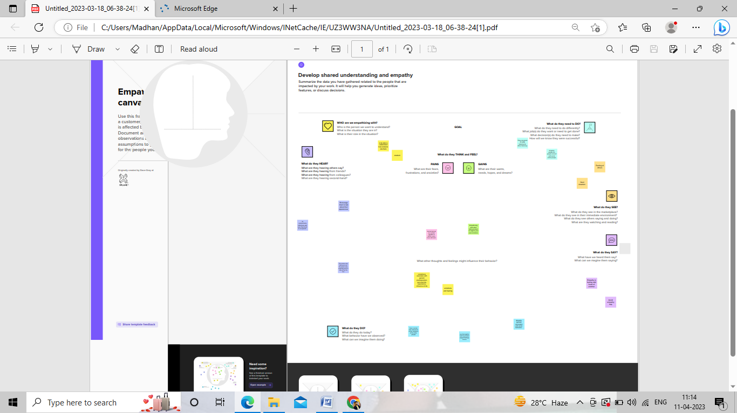

**2.2 Ideation & Brainstorming Map**

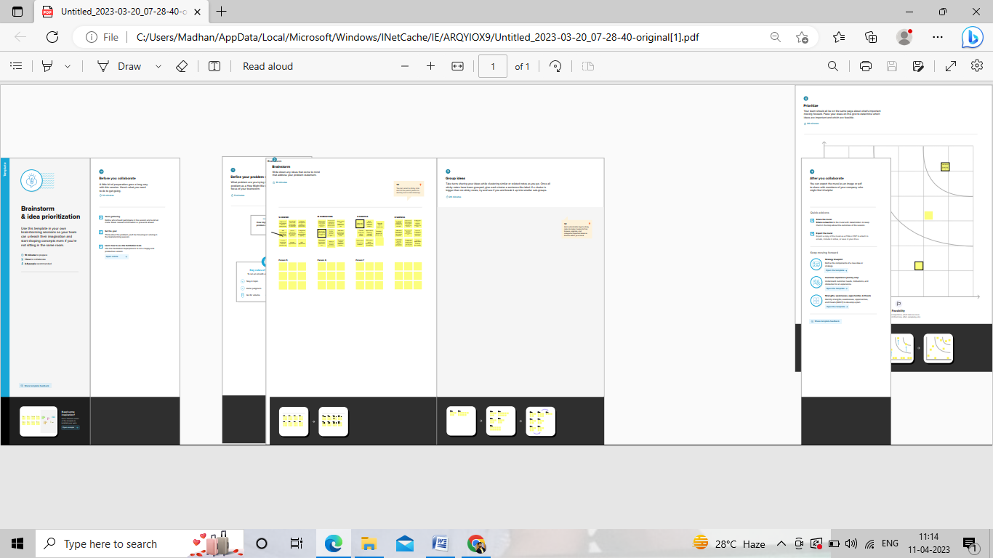

**3. RESULT**

**3.1 Data Model**

|  |  |
| --- | --- |
| **Object name** | **Fields in the Object** |
| obj1  Passport | |  |  | | --- | --- | | Field label | Data type | | Passport Number | Text | | Contact Number | Number | |
| **Obj2**  **Visa slot** | |  |  | | --- | --- | | Field label | Data type | | Location | Text | | Visa slot number | Number | |

**3.2 Activity & Screenshot**



**4. Trailhead Profile Public URL**

**Team Lead – https://trailblazer.me/id/sseenuvasan**

**Team Member 1 – https://trailblazer.me/id/smurugan107**

**Team Member 2 –https://trailblazer.me/id/sssdhoni**

**Team Member 3 -https://trailblazer.me/id/varsr13**

**5. ADVANTAGES & DISADVANTAGES**

**Advantages :**

Improves Customer Service

A CRM system manages all your contacts and aggregates lead and customer information to build profiles of everyone you interact with. This gives you easy access to important information to better understand customer behavior like purchase records and previous communications with contacts across different channels (chat, email, etc.). Customers won’t have to repeat their stories over and over to you, and you’ll be able to address issues with best practice and less effort for improved customer loyalty.

Increase in Sales

Streamlining and improving the sales process, building a sales pipeline, automating tasks, and analyzing your sales data will inevitably lead to one outcome—increased sales and sales productivity. A CRM system allows you to have all your customer-facing voice, chat, and email touchpoints accessible in one place. You’ll clinch more deals by building a repeatable, proven sales process, and delivering the right message on the right channel at just the right time.

Retain More Customers

Retention and churn rates are extremely important determiners for a company’s success; customer churn is a major obstacle to business growth. CRM tools like sentiment analysis, automated ticketing, and customer support and customer service automation can dramatically improve your retention by letting human agents defuse problems. Analytics tools that look at customer life cycle can show you when churn happens and why, so you can identify and address pain points.

Better Analytics

Analytical CRM tools make your data available, intelligible, and relevant to your business needs. All your heaps of sales data, finance data, and marketing data flow into CRM to become visible metrics, with data warehousing and data mining there to make sense of everything. The net benefit is customer acquisition, customer retention, and better data management.

Higher Efficiency

Having all your major day-to-day business functions in one place makes for better workflow, easier collaboration between team members, and better project management. Task automation eliminates menial, repetitive work and gives more time for the cognitive tasks humans are best at. Dashboards and analytics will help you gain insights into your work and optimize all kinds of business processes.

Better knowledge sharing

Miscommunication and lack of information transfer are two major time-wasters. When people take time self-learning to do things other team members already know how to do, or work on redundant tasks, you’re losing a lot of hours per week. Collaborative CRM tools can streamline your teamwork by letting you build a knowledge base, establish best practice workflows, and allowing for frictionless communication between team members.

More transparency

A CRM system allows you to foster greater transparency in your organization by assigning tasks, showing work, and delineating exactly who is who and who is doing what. If your main concern is sales, you can make use of performance tracking for individual sales agents. A CRM platform allows everyone in your organization to gain visibility on your business processes, fostering more mutual understanding and collaboration.

**Disadvantages:**

**Potential drawbacks of CRM systems**

* software subscription or purchase fees.
* premium upgrades, eg add-on marketing or reporting features.
* customisation.
* IT resources needed.
* hardware or software requirements.
* staff training and upskilling.

**6. Application**

**Tracking Customers**

**A good CRM helps you understand your market and the needs of your customers.**As you attract more customers, a CRM makes two things clear: *who* is interested in what you have to offer, and *what* is most important to them.

When it comes to winning more customers, a CRM helps you make smarter decisions than your competition and offer people what they truly want. And if customers leave or your sales stagnate, you can see common threads and change the process accordingly, to better meet their needs and retain them.

**Collecting Data for Marketing**

When you’re working in spreadsheets and scrolling through email chains, it’s hard to get a big picture of all the important data about current and future customers. **A CRM saves important data in extensive customer and contact lists.**

This makes it easy and efficient to market directly to them based on particular criteria.

**Improving Interactions and Communications**

When your list of customers is short, it’s easy to keep up with everyone. However, as your business grows and that list becomes longer, it’s more likely that sales opportunities and current customers may fall through the cracks.

**A good CRM helps you maintain great customer relationships with all your clients and let them know what your products and services can do for them.**

As you make updates and enhance your offerings over time, customer relationship management software allows you to keep them in the loop and include them in important news.

**Streamlining Internal Sales Processes**

Because every salesperson operates differently, things can get inefficient quickly!

**A good CRM helps you streamline your internal sales processes so that there is consistency and quality across your sales team.**

This is the secret to how companies can promise, and consistently deliver, great customer service – having one place where all the customer information lives, and the processes to back it up.

A streamlined internal process also makes it easier to hire, train, and share customer information with new salespeople when there is a turnover in your sales team. With less time spent in CRM systems and more time interacting with customers and building their customer experience, your sales reps can thrive.

**Planning Your Operations**

**A good customer relationship management tool will help you understand your current capacity and the demand customers are likely to have for your products and services.**

This means you will see trends and be informed faster as things grow and change. A CRM helps you know when it’s time to hire more people, alter internal processes, or invest resources into more production, before growing pains and panic sets in.

Implementing an operational CRM platform means choosing to break through the ceiling of your sales potential.

By accessing valuable insights that help you make better decisions, using customer insights to gain an upper hand on your competition, and developing processes that allow you to provide the same high quality of service even as your customer base grows, consider CRM solutions at the beginning of the next chapter for your business.

**7. Conclusion :**

Customer Relationship Management enables a company to align its strategy with the needs of the customer in order to best meet those needs and thus ensure long-term customer loyalty. However, in order to be successful in these aims, the different company departments have to work together and use measures in a coordinated fashion. This purpose is achieved via a customer database which is analyzed and updated using CRM software.

This approach will be of particular interest to companies operating in highly competitive markets where it is difficult to attract new customers**.**

**8. FUTURE SCOPE :**

The future of CRM is bright. CRM will continue to report key data and give insight for future action, however, leading experts see CRM evolving to measure and inform sales enablement and customer engagement while playing a tremendous role in the success of future business.

At this session of Dreamforce, led by John Taschek Senior Vice President of Market Strategy at Salesforce, panelists Paul Greenberg, Denis Pombriant, and Ray Wang weigh in on important considerations for the future of sales, marketing, and customer engagement. These leading CRM experts recommend the following measures for future-proofing your company’s sales:

Unify Sales, Marketing, and Operations Around Common Goals and Definitions

The evolution of CRM will facilitate the aligning of sales and marketing even more closely, says Paul Greenberg, author of CRM at the Speed of Light. Gone are the days when sales and marketing can expend effort on internal conflicts. In order to thrive in the future landscape of sales, organisations must seek to unify sales, marketing, and operations around common goals and definitions.

Sales enablement, the fusion of sales, marketing, and operations, will share goals and have common messaging and materials to the point where marketing may even have revenue targets. Marketing, sales, and customer service will need to more closely align, says Greenberg. Marketing will primarily be responsible for getting the customers’ attention and providing extensive content. Sales will need to become subject matter experts. Customer service will provide communities that capture information and bring people together.